Certificate of Attendance

This is to certify that Jasmine Jackson
From St. Mary Magdalen’s Montessori

Visited ‘Toddlers the world over: What works for wellbeing and why it matters!
An international perspective through the ToWe project’

At Kingston University

As part of a The ToWe Project - Multiplier Event – Local Training Event Workshop
ERASMUS+ Key Action 201 School Education Strategic Partnerships
On Wednesday, 10th January, 2018
Signed 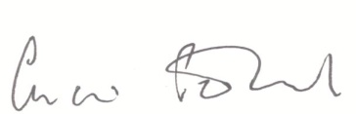

Name Charis Penfold
Position of Signatory AfC Director of Education Date 10th January, 2018

