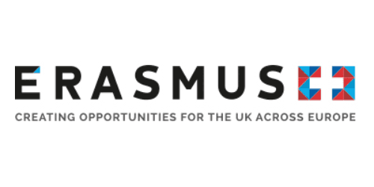

Certificate of Attendance

This is to certify that Kim Boatswain-Medlar (name of attendee)
From NEWTEC College (name of institution)

Visited Kingston University, Kingston Hill, Kingston upon Thames, Surrey, KT2 7LB
As part of a The ToWe Project – Multiplier Event – International Training Event Workshop
ERASMUS+ Key Action 201 School Education Strategic Partnerships
on 16 March 2018

