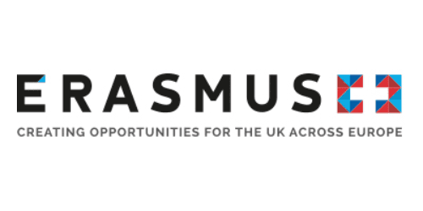

Certificate of Attendance

This is to certify that Michelle Demirtas (name of attendee)
From Bright Horizons Family Solutions (name of institution)

Visited Kingston University, Kingston Hill, Kingston upon Thames, Surrey, KT2 7LB
As part of a The ToWe Project – Multiplier Event – International Training Event Workshop
ERASMUS+ Key Action 201 School Education Strategic Partnerships
on 16 March 2018

