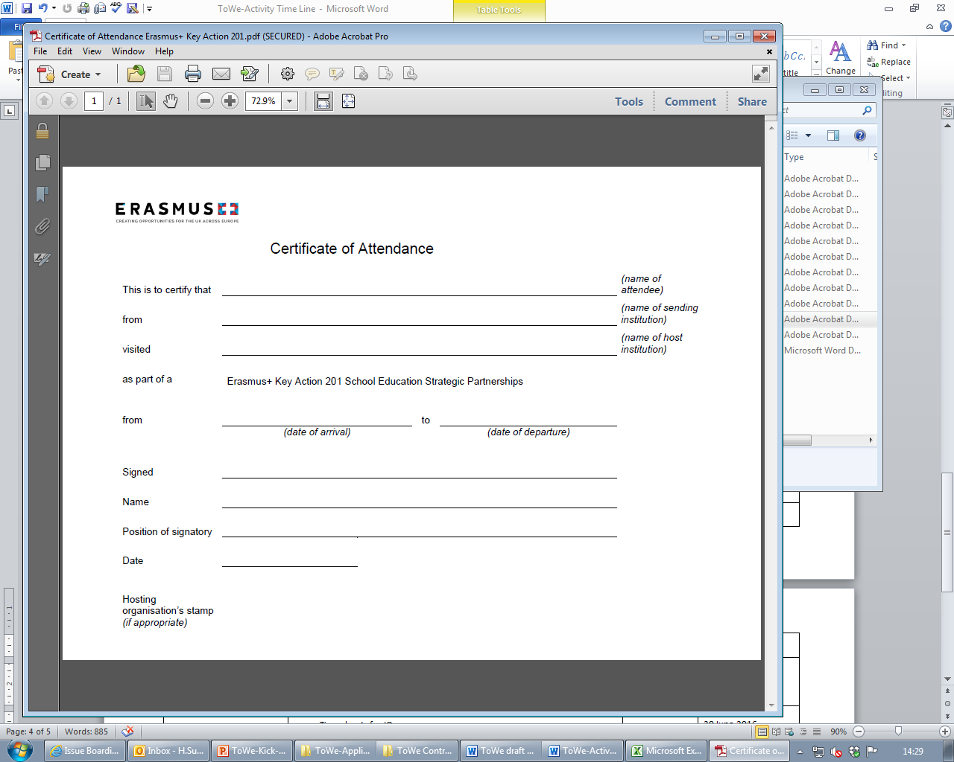**Certificate of Attendance**

This is to certify that Helen Sutherland

From Kingston University, London

Visited Kingston University, Kingston Hill, Kingston upon Thames, Surrey, KT2 7LB

As part of a ERASMUS+ Key Action 201 School Education Strategic Partnerships

From 14th March 2016 to 18th March 2016

Signed 

Name Marcus Bhargava

Position of Signatory Head of the School of Education

Date 18th March 2016

Hosting organisation’s stamp

**Certificate of Attendance**

This is to certify that Yasmin Mukadam

From Kingston University, London

Visited Kingston University, Kingston Hill, Kingston upon Thames, Surrey, KT2 7LB

As part of a ERASMUS+ Key Action 201 School Education Strategic Partnerships

From 14th March 2016 to 18th March 2016

Signed 

Name Marcus Bhargava

Position of Signatory Head of the School of Education

Date 18th March 2016

Hosting organisation’s stamp

**Certificate of Attendance**

This is to certify that Monika Röthle

From Universitetet I Stavanger

Visited Kingston University, Kingston Hill, Kingston upon Thames, Surrey, KT2 7LB

As part of a ERASMUS+ Key Action 201 School Education Strategic Partnerships

From 14th March 2016 to 18th March 2016

Signed 

Name Marcus Bhargava

Position of Signatory Head of the School of Education

Date 18th March 2016

Hosting organisation’s stamp

**Certificate of Attendance**

This is to certify that Yngve Rosell

From Universitetet I Stavanger

Visited Kingston University, Kingston Hill, Kingston upon Thames, Surrey, KT2 7LB

As part of a ERASMUS+ Key Action 201 School Education Strategic Partnerships

From 14th March 2016 to 18th March 2016

Signed 

Name Marcus Bhargava

Position of Signatory Head of the School of Education

Date 18th March 2016

Hosting organisation’s stamp

**Certificate of Attendance**

This is to certify that Maria Gilje Tjorheim

From Universitetet I Stavanger

Visited Kingston University, Kingston Hill, Kingston upon Thames, Surrey, KT2 7LB

As part of a ERASMUS+ Key Action 201 School Education Strategic Partnerships

From 14th March 2016 to 18th March 2016

Signed 

Name Marcus Bhargava

Position of Signatory Head of the School of Education

Date 18th March 2016

Hosting organisation’s stamp

**Certificate of Attendance**

This is to certify that Cristina Corcoll

From Universitat Ramon Llull

Visited Kingston University, Kingston Hill, Kingston upon Thames, Surrey, KT2 7LB

As part of a ERASMUS+ Key Action 201 School Education Strategic Partnerships

From 14th March 2016 to 18th March 2016

Signed 

Name Marcus Bhargava

Position of Signatory Head of the School of Education

Date 18th March 2016

Hosting organisation’s stamp

**Certificate of Attendance**

This is to certify that Àngels Geis

From Universitat Ramon Llull

Visited Kingston University, Kingston Hill, Kingston upon Thames, Surrey, KT2 7LB

As part of a ERASMUS+ Key Action 201 School Education Strategic Partnerships

From 14th March 2016 to 18th March 2016

Signed 

Name Marcus Bhargava

Position of Signatory Head of the School of Education

Date 18th March 2016

Hosting organisation’s stamp

**Certificate of Attendance**

This is to certify that Carme Flores

From Universitat Ramon Llull

Visited Kingston University, Kingston Hill, Kingston upon Thames, Surrey, KT2 7LB

As part of a ERASMUS+ Key Action 201 School Education Strategic Partnerships

From 14th March 2016 to 18th March 2016

Signed 

Name Marcus Bhargava

Position of Signatory Head of the School of Education

Date 18th March 2016

Hosting organisation’s stamp

**Certificate of Attendance**

This is to certify that Alison McGee

From Achieving for Children

Visited Kingston University, Kingston Hill, Kingston upon Thames, Surrey, KT2 7LB

As part of a ERASMUS+ Key Action 201 School Education Strategic Partnerships

From 14th March 2016 to 18th March 2016

Signed 

Name Marcus Bhargava

Position of Signatory Head of the School of Education

Date 18th March 2016

Hosting organisation’s stamp

**Certificate of Attendance**

This is to certify that Kathryn Hogarth

From Achieving for Children

Visited Kingston University, Kingston Hill, Kingston upon Thames, Surrey, KT2 7LB

As part of a ERASMUS+ Key Action 201 School Education Strategic Partnerships

From 14th March 2016 to 18th March 2016

Signed 

Name Marcus Bhargava

Position of Signatory Head of the School of Education

Date 18th March 2016

Hosting organisation’s stamp

**Certificate of Attendance**

This is to certify that Thomas Maybey

From Achieving for Children

Visited Kingston University, Kingston Hill, Kingston upon Thames, Surrey, KT2 7LB

As part of a ERASMUS+ Key Action 201 School Education Strategic Partnerships

From 14th March 2016 to 18th March 2016

Signed 

Name Marcus Bhargava

Position of Signatory Head of the School of Education

Date 18th March 2016

Hosting organisation’s stamp

**Certificate of Attendance**

This is to certify that Janette Barber

From Achieving for Children

Visited Kingston University, Kingston Hill, Kingston upon Thames, Surrey, KT2 7LB

As part of a ERASMUS+ Key Action 201 School Education Strategic Partnerships

From 14th March 2016 to 18th March 2016

Signed 

Name Marcus Bhargava

Position of Signatory Head of the School of Education

Date 18th March 2016

Hosting organisation’s stamp

**Certificate of Attendance**

This is to certify that Hannah Denyer

From Achieving for Children

Visited Kingston University, Kingston Hill, Kingston upon Thames, Surrey, KT2 7LB

As part of a ERASMUS+ Key Action 201 School Education Strategic Partnerships

From 14th March 2016 to 18th March 2016

Signed 

Name Marcus Bhargava

Position of Signatory Head of the School of Education

Date 18th March 2016

Hosting organisation’s stamp

**Certificate of Attendance**

This is to certify that Maiken Gimre

From Sandnes Kommune

Visited Kingston University, Kingston Hill, Kingston upon Thames, Surrey, KT2 7LB

As part of a ERASMUS+ Key Action 201 School Education Strategic Partnerships

From 14th March 2016 to 18th March 2016

Signed 

Name Marcus Bhargava

Position of Signatory Head of the School of Education

Date 18th March 2016

Hosting organisation’s stamp

**Certificate of Attendance**

This is to certify that Nicolle De Graaf

From Sandnes Kommune

Visited Kingston University, Kingston Hill, Kingston upon Thames, Surrey, KT2 7LB

As part of a ERASMUS+ Key Action 201 School Education Strategic Partnerships

From 14th March 2016 to 18th March 2016

Signed 

Name Marcus Bhargava

Position of Signatory Head of the School of Education

Date 18th March 2016

Hosting organisation’s stamp

**Certificate of Attendance**

This is to certify that Lillian Bakken

From Sandnes Kommune

Visited Kingston University, Kingston Hill, Kingston upon Thames, Surrey, KT2 7LB

As part of a ERASMUS+ Key Action 201 School Education Strategic Partnerships

From 14th March 2016 to 18th March 2016

Signed 

Name Marcus Bhargava

Position of Signatory Head of the School of Education

Date 18th March 2016

Hosting organisation’s stamp

**Certificate of Attendance**

This is to certify that Harrieth Elin Kristiansen Strøm

From Sandnes Kommune

Visited Kingston University, Kingston Hill, Kingston upon Thames, Surrey, KT2 7LB

As part of a ERASMUS+ Key Action 201 School Education Strategic Partnerships

From 14th March 2016 to 18th March 2016

Signed 

Name Marcus Bhargava

Position of Signatory Head of the School of Education

Date 18th March 2016

Hosting organisation’s stamp

**Certificate of Attendance**

This is to certify that Liv Hjertø

From Sandnes Kommune

Visited Kingston University, Kingston Hill, Kingston upon Thames, Surrey, KT2 7LB

As part of a ERASMUS+ Key Action 201 School Education Strategic Partnerships

From 14th March 2016 to 18th March 2016

Signed 

Name Marcus Bhargava

Position of Signatory Head of the School of Education

Date 18th March 2016

Hosting organisation’s stamp

**Certificate of Attendance**

This is to certify that Maj Gabrielsen

From Sandnes Kommune

Visited Kingston University, Kingston Hill, Kingston upon Thames, Surrey, KT2 7LB

As part of a ERASMUS+ Key Action 201 School Education Strategic Partnerships

From 14th March 2016 to 18th March 2016

Signed 

Name Marcus Bhargava

Position of Signatory Head of the School of Education

Date 18th March 2016

Hosting organisation’s stamp

**Certificate of Attendance**

This is to certify that Silvia Turmo

From Petita Escola - SINATURMO SL

Visited Kingston University, Kingston Hill, Kingston upon Thames, Surrey, KT2 7LB

As part of a ERASMUS+ Key Action 201 School Education Strategic Partnerships

From 14th March 2016 to 18th March 2016

Signed 

Name Marcus Bhargava

Position of Signatory Head of the School of Education

Date 18th March 2016

Hosting organisation’s stamp

**Certificate of Attendance**

This is to certify that Natalia Turmo

From Petita Escola - SINATURMO SL

Visited Kingston University, Kingston Hill, Kingston upon Thames, Surrey, KT2 7LB

As part of a ERASMUS+ Key Action 201 School Education Strategic Partnerships

From 14th March 2016 to 18th March 2016

Signed 

Name Marcus Bhargava

Position of Signatory Head of the School of Education

Date 18th March 2016

Hosting organisation’s stamp

**Certificate of Attendance**

This is to certify that

From Achieving for Children

Visited Kingston University, Kingston Hill, Kingston upon Thames, Surrey, KT2 7LB

As part of a ERASMUS+ Key Action 201 School Education Strategic Partnerships

On the 14th March 2016

Signed 

Name Marcus Bhargava

Position of Signatory Head of the School of Education

Date 18th March 2016

Hosting organisation’s stamp

**Certificate of Attendance**

This is to certify that Maria Jose Riella

From Mas Balmanya –Suara

Visited Kingston University, Kingston Hill, Kingston upon Thames, Surrey, KT2 7LB

As part of a ERASMUS+ Key Action 201 School Education Strategic Partnerships

From 14th March 2016 to 18th March 2016

Signed 

Name Marcus Bhargava

Position of Signatory Head of the School of Education

Date 18th March 2016

Hosting organisation’s stamp

**Certificate of Attendance**

This is to certify that Mireia Miralpeix

From Mas Balmanya –Suara

Visited Kingston University, Kingston Hill, Kingston upon Thames, Surrey, KT2 7LB

As part of a ERASMUS+ Key Action 201 School Education Strategic Partnerships

From 14th March 2016 to 18th March 2016

Signed 

Name Marcus Bhargava

Position of Signatory Head of the School of Education

Date

Hosting organisation’s stamp

**Certificate of Attendance**

This is to certify that Anna Nicolau

From Mas Balmanya –Suara

Visited Kingston University, Kingston Hill, Kingston upon Thames, Surrey, KT2 7LB

As part of a ERASMUS+ Key Action 201 School Education Strategic Partnerships

From 14th March 2016 to 18th March 2016

Signed 

Name Marcus Bhargava

Position of Signatory Head of the School of Education

Date

Hosting organisation’s stamp