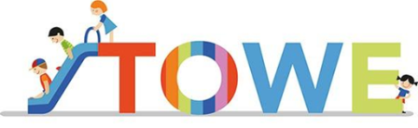

Invitation to local workshop – Toddlers Wellbeing
A European project to enhance the education and wellbeing of Toddlers from diverse backgrounds through the development of training, and development of training and materials to support early year practitioners
Target group: Early years practitioners and Head (administrators) that work in kindergartens in the municipality of Sandnes.

December 7th - 2017 – 09.00 – 15.00
University of Stavanger – Auditorium 1- Kjell Arholms Hus
The universities in Stavanger, Barcelona and Kingston (London), have in cooperation with the Sandvedhaugen barnehage and kindergarten in Barcelona and Kingston have worked together in a toddlers’ wellbeing project to enhance toddlers’ education and wellbeing.
The universities have developed four manuals, which have been used to educate early year’s practitioners in toddlers’ mealtimes, toddlers’ wellbeing, toddlers’ voice and expression and children’s additional language.
The kindergartens have contributed by trying out the manuals and given feedback on them.
This workshop will provide insight to the different manuals and our experiences after using them. Toddler’s wellbeing also fits in well with the new Norwegian frame plan.

Programme:
09.00-10.00 The importance of the ToWe material and what it is (Monika Röthle, Yngve Rosell).
- The ToWe project: to learn from each other
- Using the material to train and to support early year practitioners.
- Wellbeing – a key concept to an overall approach
10.15 – 11.00 Parallel sessions*
11.00 – 11.45 Lunch
11.45 – 12.30 Parallel sessions*
12.45 – 13.30 Parallel sessions*
13.45- 15.00 Learning from each other and where to go from here
* Toddlers wellbeing (Liv Hjertø), Toddlers mealtime (Harrieth Elin Kristiansen Strøm) and Toddlers voice and expression (Maj Gabrielsen)
The workshop is free of charge, for a maximum of a 150 participants.

