http://www.healthcare.ac.uk/school-of-education-wins-erasmus-grant-for-new-partnership-project/

School of Education wins Erasmus+ grant for new partnership project
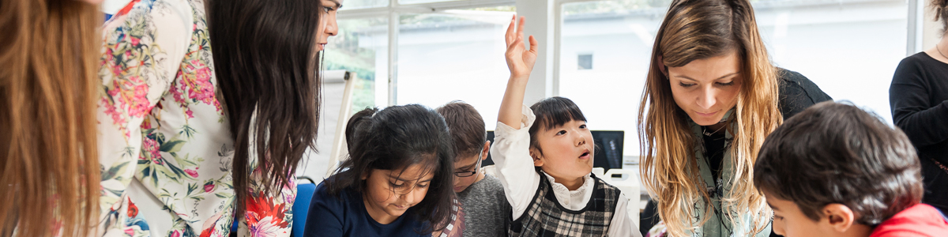
The School of Education has been awarded just under €350,000 for a new Strategic Partnership project under the Erasmus+ scheme. The three-year project, entitled “Enhancing the education and wellbeing of disadvantaged toddlers through the development of training and materials to support early years practitioners” will be coordinated by Kingston University and led by Helen Sutherland, Senior Lecturer and Course Director for Early Years Initial Teacher Training. Helen will be working with Stavanger University in Norway and Ramon Llull University in Barcelona, together with four early years settings and local authorities in the three regions, including Achieving for Children in Kingston.
The aim of the project is to provide a unique continuing professional development opportunity (CPD) for early years practitioners in the three partner countries, focussing on the needs of disadvantaged toddlers, using a more holistic approach which addresses the wellbeing of the child. The project will build on work undertaken in a previous Comenius project, TODDLER, which developed some initial materials. In partnership with practitioners and other stakeholders the project will test and develop a suite of instruments and strategies which will be of practical use to early years practitioners in the partner countries and elsewhere.
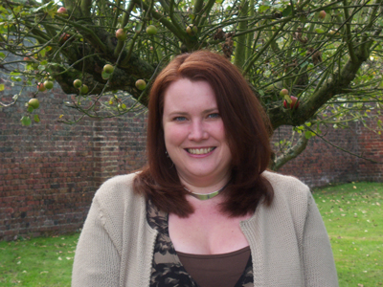
Principal investigator, Helen Sutherland, has just returned from presenting with a Swedish colleague at the European Early Childhood Education Research Association Conference (EECERA). She is excited by the new project which will further the work of TODDLER and the European exchanges she has developed for early years practitioners. “This Erasmus+ project will provide a wonderful training opportunity for practitioners in an area of education which is often overlooked. We know that a child’s experience and education from birth to five is critical and can determine their future. We therefore hope to develop materials and training models which can impact on the education of disadvantaged toddlers, to give them a better start to their learning journey.”
Marcus Bhargava, Head of the School of Education, said “This is a great opportunity for the School to lead a European project which will have an impact on an important area of education. This success recognises our expertise and experience in early years and will strengthen our links in Europe and with local service providers.”
6th October 2015

