

**Heathfield**

**Children’s Centre**

**Where are we?**

**What do we offer?**

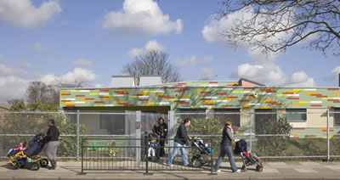

**Session Information Booklet**

**Stay & Play sessions**

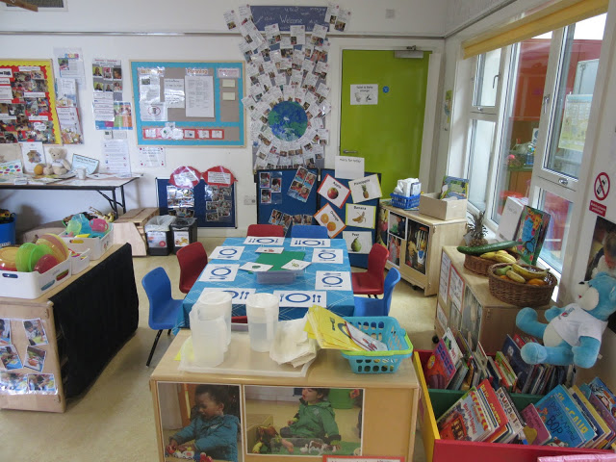

**Inside**

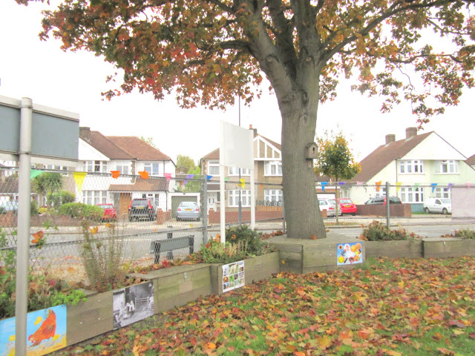

**Outside**

**Outside**

‘Stay & Play’ is the core provision that all Children’s Centres provide, and it is our most popular group.

We currently have 3 sessions per week at the Centre, two on Monday morning and one on Friday morning, with another provided at an Outreach site – Whitton Youth Zone. Janette uses the ‘Early Years Foundation Stage’ framework to provide a stimulating and age –appropriate learning environment for children and their parents / carers.

The aims of the session are to support children’s learning and development through play, through planning for the interests and needs of the children in order that they achieve their next steps, and to inform parents/carers about child development, modelling this through effective practice and sharing ways in which parents can support their children to be independent and resilient.

‘Snack café’ is an integral part of the session, where children’s independence, social skills and also communication skills are supported.

As with all the sessions, parents stay with their children, and can ask staff members for advice and support. Staff can refer the family to other agencies including health visitors and the speech and language therapist.

Leaflets and song sheets are available for parents to take home to support an effective home learning environment.

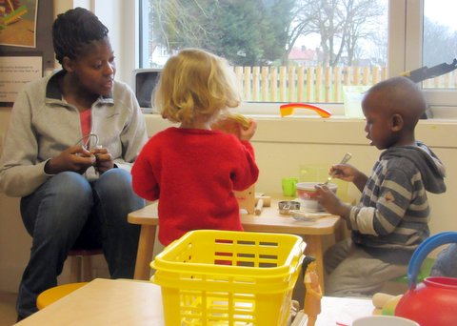

**Fun and learning with our parents**

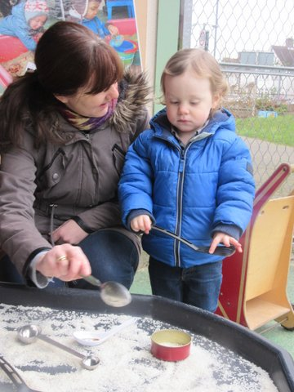 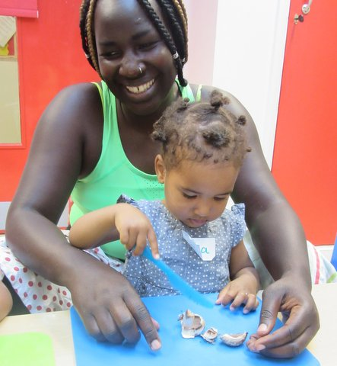

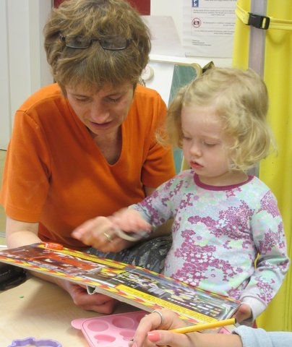

**Exploring and discovering**

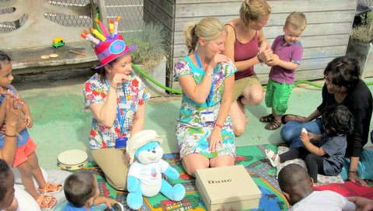

**Talking with Speech & Language Therapists**

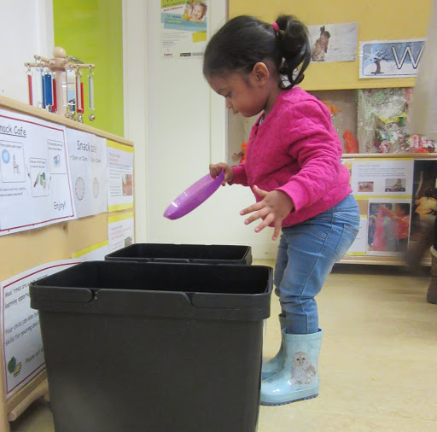

**Developing independence**

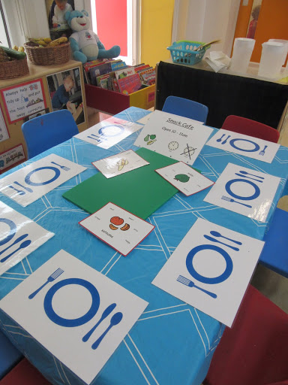

**Learning about eating together**

Newsletter **January 2017**

Welcome to ‘Stay and Play’

We provide opportunities for parents, carers and children to learn and play together through our ‘Stay and Play’ sessions and holiday activities.

Please help us to create a positive learning environment for your child by letting us know if your child has any special interests - we will do our best to make sure that those interests are supported through our activities.

Celebrating diversity

All children and parents are warmly welcomed into our sessions. Young children of every cultural and ethnic background need to develop a secure and positive sense of their own identity. Children’s family life is the most significant source of that identity.

Tell us if your family are celebrating a special social or cultural event as we may be able to acknowledge this through our activities, songs and displays.

We are grateful to receive donations of items that reflect different cultures and ethnic backgrounds. We need items that are in good condition and are suitable for young children to play with - for example; dolls, small play figures, home corner equipment such as dressing-up clothes, baby blankets, fabrics, kitchen items (non-breakable), biscuit tins, tea caddies, children’s books in other languages and other resources which show the variety of scripts used within our community.

Wow Moments!

Being acknowledged and affirmed by important people in their lives leads to children gaining confidence and inner strength (Early Years Foundation Stage, EYFS). For this reason we would like to celebrate your child’s achievements, great and small - we call these ‘Wow’ moments.

We have provided ‘Wow cards’ for you to record those moments when your child says or does something that makes you think 'Wow'! Examples of your child’s ‘Wow’ moments could be that he or she: tried a new activity, joined in with songs, shared playdough with another child, talked to another adult or child, helped to tidy up their play things, tried a new fruit at snack time. **Every child is unique** and we want to celebrate and display all their individual achievements on our’ Wow Wall’.

Please record any ‘Wow’ moments that happen at home or in the centre for us to celebrate and display on our ‘Wow’ wall.

We are keen to record lots of 'Wow' moments this term!

Other information

Heathfield Children's Centre is here to offer information, advice and support to parents and carers of children 0-5 years. We can offer advice on health and education services, local childcare, education, and training and employment opportunities for parents and family support services. Please speak to a member of staff for more information.

Take a look at our **programme** or look on website and find out what’s going on at Heathfield Children's Centre and other Children Centre’s in the Richmond Borough.

The team would like to thank you for your continued support.

Heathfield Children’s Centre, Powder Mill Lane, Whitton, TW2 6EX

Tel: 020 8734 3405

heathfieldcc@achievingforchildren.org.uk

**‘Little Explorers’**

We would like to invite you and your child to come to our

**‘Little Explorers’ session**

**Tuesdays from 9.30-11.00**

This is an invitation-only ‘Stay and Play’, as it is for a smaller group of children.

* In this small session we plan carefully for each child’s individual learning,
* We, together, will notice and celebrate exciting moments that you and your child experience.
* We will keep a ‘Learning Diary’ for your child – this is a lovely record of your child’s learning and development for you to keep.

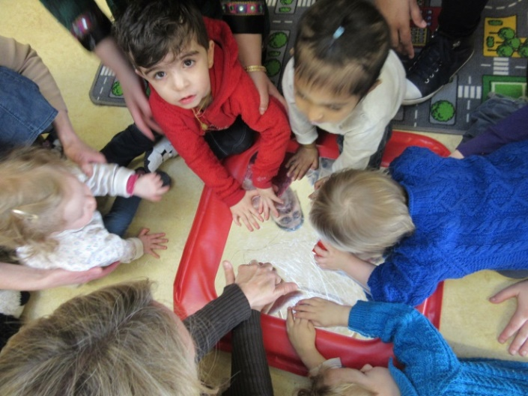

**Exploring with skilled practitioners**

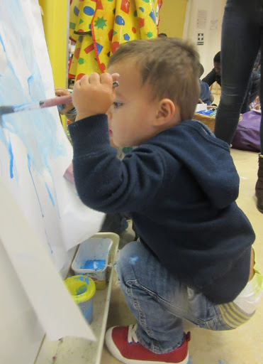

**A very warm welcome to Heathfield!**

**We do hope that you enjoy visiting our sessions!**

***Janette, Jill, Debbie and team***

**Following our own interests**