

**Moor Lane Day Nursery**

**Where are we?**

**What do we offer?**

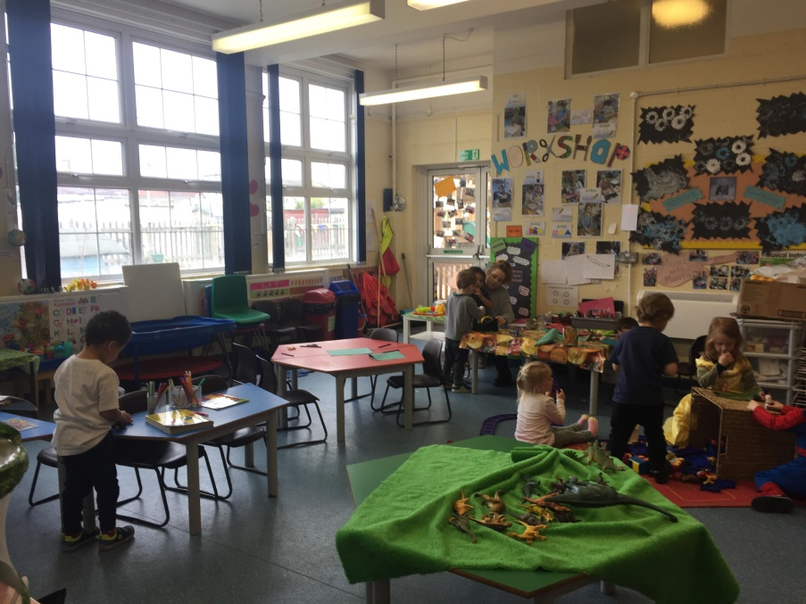

**Session Information Booklet**

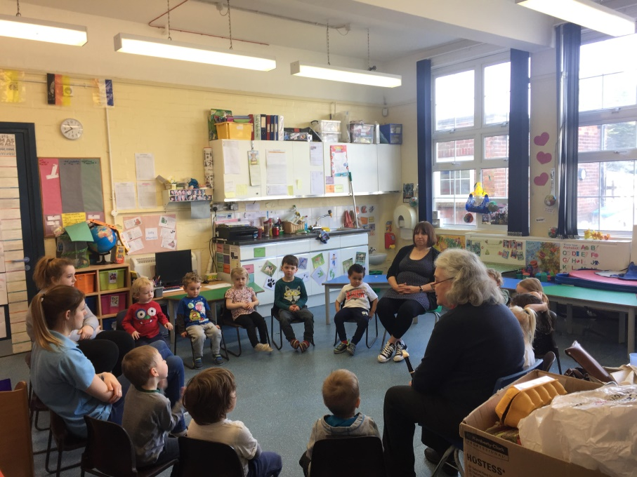

**Inside**

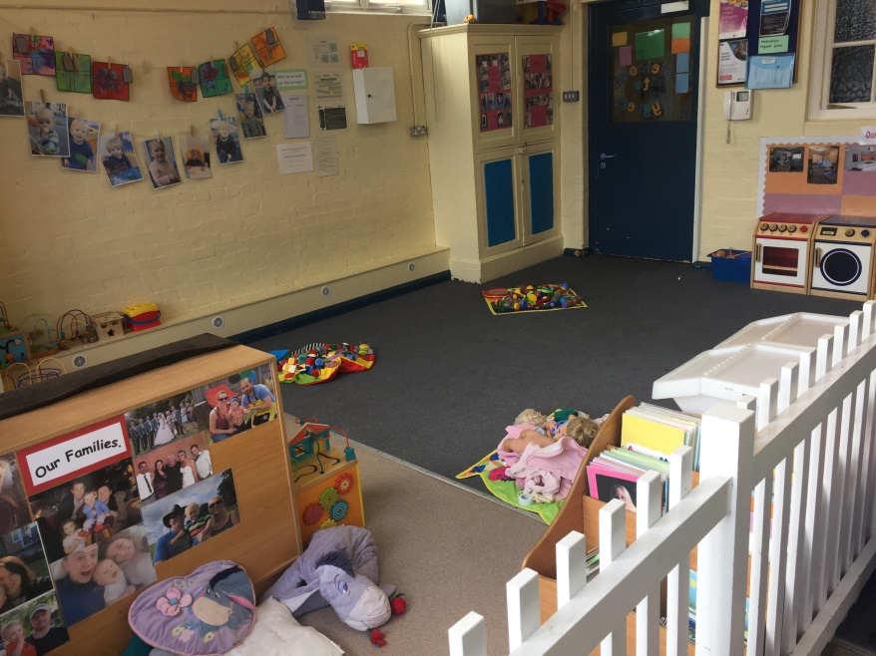

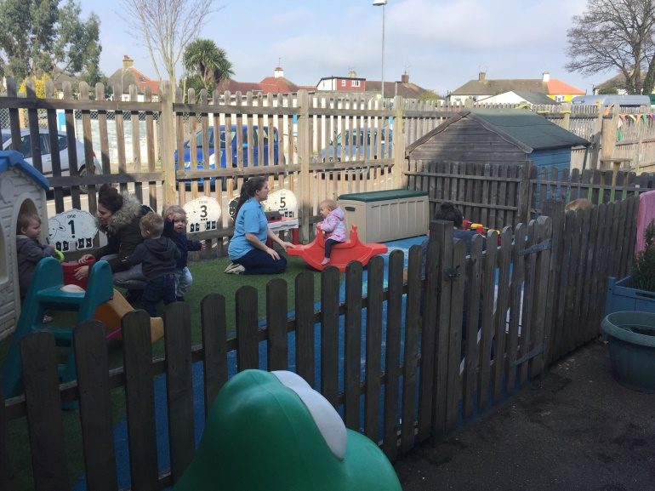

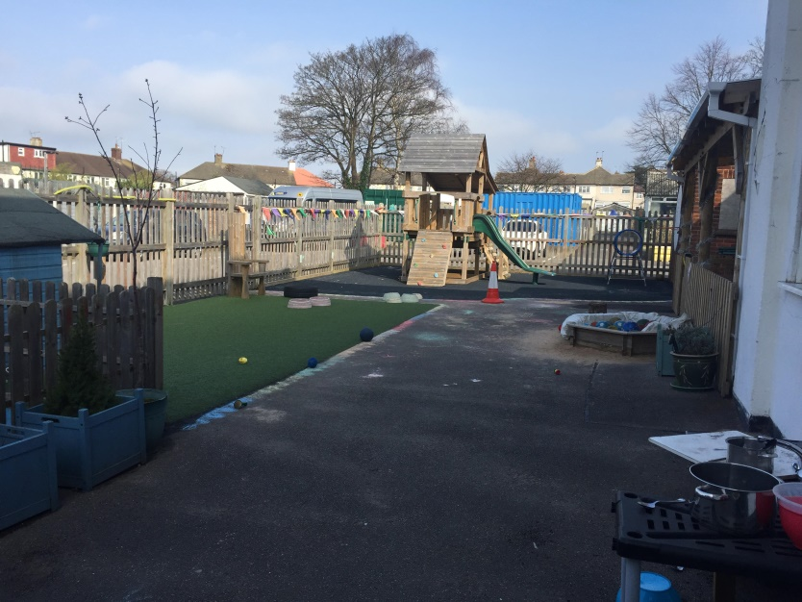

**Outside**

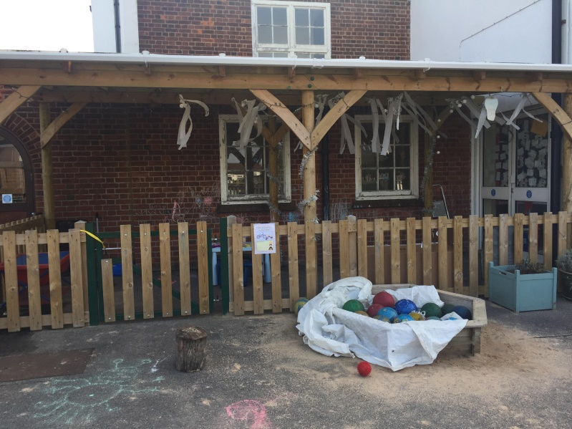

**MOOR LANE DAY NURSERY**

**Moor Lane Centre**

**Moor Lane Chessington Surrey KT9 2AA**

Telephone: 020 8391 2113

E mail: [moorlanedaynursery@achievingforchildren.org.uk](mailto:moorlanedaynursery@achievingforchildren.org.uk)

**MC900013226[1]**

**Welcome to Moor Lane Day Nursery**

The nursery team aims to provide quality childcare in a happy and stimulating environment where each child may develop to his/her full potential in accordance with the ’Early Years Foundation Stage’ and OFSTED requirements.

## Mission statement

The Nursery is registered with OFSTED for twenty-three children. Six places for children from three months to two years, seventeen places for children two to five years.

We welcome children and families regardless of their ethnic origin, religious background, dietary needs, disability, behaviour or sexual orientation.

We welcome applications from families either living or working in the borough of Kingston, surrounding areas or commuting to further afield.

Siblings have priority, otherwise, places are offered on first come, first served basis. We operate a waiting list when the nursery is over subscribed.

Due to the size of the nursery and the fact it is self-funding we are unable to keep places open for emergencies.

We ensure that existence of our nursery is widely advertised in places accessible to all sections of the community.

We ensure that information about the nursery is accessible – in written and spoken form and where appropriate, in different languages. Where necessary, we will try to provide information in Braille or through signing or an interpreter.

We are flexible about attendance patterns to accommodate the needs of individual children and families

## Hours

Nursery hours are 8 a.m. - 6 p.m. Monday to Friday for 51 weeks of the year. Excluding Bank Holidays **the nursery closes @ 3 p.m. on Christmas Eve and re-opens after New Year bank holiday.** We also close for an inset day on an annual basis, for which we give plenty of notice.

**NURSERY FEES / PAYMENTS**

Payments should be paid on the 1st of each month, in advance and are calculated by 51weeks divided by 12 Months. **Childcare vouchers can also be used.**

**Early years funding** is available for children in the term after their 3rd Birthday i.e. January, April and September, this is 15 hours per week. This is divided by how many weeks there are in a term. (38 weeks a year). This does mean that grant in summer term is spread over 5 months.

Some children are entitled to **2:15 funding, the term after they are two**. Please contact [fis@kingston.gov.uk](mailto:fis@kingston.gov.uk) to check your child’s eligibility.

**SECURING A PLACE FOR YOUR CHILD**

Following your enquiry and visit to the nursery, should you wish to apply for a place for your child you must complete the registration form outlining the days that you require and return the completed form to the Nursery Manager. Your child will be placed on our waiting list.

The nursery will then call you to confirm whether a place is available 3 months before your chosen start date. Should you choose to accept this place, please do so in writing and enclose the appropriate deposit amount.

**Cygnets: 3 months – 2 years**

In Cygnets, we have a flexible day to take into consideration the age range of the children using the EYFS guidance (Early Years Foundation stage, September 2012)

There are two qualified members of staff for six children - **1:3 ratio.**

We set the room out to incorporate the Early Years Foundation Stage and the seven areas of learning. We base the curriculum activities provided from the observations of children’s developmental needs.

Children are given opportunities to explore and experiment with a wide range of resources.

We are equipped to stimulate and develop your child, whilst at the same time providing a “homely” atmosphere. We provide both developmentally suitable toys and heuristic play.

The Cygnets have their own fenced area in the garden.

There is provision for both quiet and noisy times. Children have opportunities to experience “messy” activities, including sand, water, paint and playdough. There is suitable protective clothing provided for all these activities.

The youngest babies have their own designated cots. Once the children have reduced their sleep to once a day, they sleep on child-sized mattresses on the floor. Staff monitor sleeping children at all times.

Home cooked food is served and meals are eaten around a low table, with the youngest children in low chairs and older children in “captain” chairs with safety straps. The cook purees the same meals for the youngest children, taking into account their dietary requirements.

We have a chart displayed on the wall so parents can see what their child has eaten.

Nappies are regularly changed before lunch and after tea and at any other time necessary. Nappy changes are logged on a chart.

The nursery staff team are responsible for making up the bottles, which are steamed sterilized. A chart is kept of bottles/amount/timing that each child requires.

A daily diary is kept; this contains information on how the child has eaten and slept and any other relevant information activities. This diary is kept until the child is twelve months old. The parent can also use it to write down information or messages.

**Swans: 3 months – 2 years**

In the Swans room while still allowing for free play during the day, the routine allows for more structure in that the children will be encouraged to participate in specific planned curriculum learning related activities.

Older children will also have the opportunity to work in a group or individually according to their needs. This is to impart an attitude to learning through – books, experimentation, interacting with adults and children.

We work in accordance with the Curriculum Guidelines for the Early Years Foundation Stage which is the national guidance for children, aged 0 – 4+. All areas of the curriculum will be involved in our routine.

We use the ‘Letters and Sounds’ phonic scheme (phase 1) to introduce children to how the alphabet works, preparing them for reading and writing. This scheme encourages children to learn the sounds of letters by playing an active part in a group learning experimentation by playing games, reading and listening. We use the Jolly Phonics reading scheme and this is encouraged with our sound tube game.

We have music and movement sessions and we aim to extend the children’s gross motor skills with balancing and climbing activities. The children also take part in circle games and races. We have a music teacher who comes in once a week on a rota basis to do music with children.

We also aim, perhaps at this age the most important of all, to develop a caring attitude to other children and their environment, respect for others’ physical welfare and emotional well- being through growing independence, autonomy and self- respect.

Children can choose whether to play inside or outside and a variety of activities reflecting the curriculum are set both indoors or outside. Access to the garden is restricted if very hot weather between 11.30am – 2pm.

At mealtimes children sit at the table with their keyworker in family groups.

**Basic Routine**

Nursery opens at 8.00 a.m.

Children arriving before 8.30 a.m. will be offered breakfast cereal, toast, fruit juice and milk.

Free play through to 8.45 a.m. Children are offered fruit with a drink of milk @ 9.50 a.m. and a self- service ‘snack bar’ for the older children.

Lunch is at 11.30 a.m. after which a trip to the bathroom to include teeth cleaning followed by rest time for the younger children.

Tea is at 3pm

Drink and a biscuit at 5.15 p.m. Activities provided until the nursery closes at 6 p.m.

Water is provided at all times.

## Partnership with parents

**Learning journeys –**Learning Journeys are a way of tracking and sharing your Child’s interest and learning (both at home and at nursery). We aim to chart your child's development whilst at nursery with photographs and written information from your child's Keyworker, and we ask you to contribute on a termly basis.

The children enjoy sharing their learning journeys with their peers, staff and parents. This enables the children to feel secure and valued by the partnership between nursery staff and parents.

The staff actively encourages parental involvement; we are all working for the physical, emotional and educational development of your child. We welcome and value parents as volunteers to support the learning curriculum and help with outings, fundraising, helping in the room and other social events.

### The children really benefit from first hand experiences. You might be able to come and share them with us – i.e. we had a parent who is a fire officer who visited the nursery.

### Marvin the Monkey - Children take it in turns to take Marvin the (toy!!) monkey home, for the weekend and have their photo taken with Marvin enjoying activities at home. These photos and accompanying descriptions are kept in a folder for all the children to share.

Themes in Swans are termly. Letters are sent home explaining the theme and giving parents suggestions to encourage and extend their children’s learning.

**Library books –** There is a selection of books for the children to choose from and take home on a monthly basis.

**White board** – Up to date messages are written for parent’s information on the white board next to the office. There is another notice board in the Cygnets room.

**Bears -** The other board has our holiday bears Spencer, Gloria, Gordon and Gertie. These bears are displayed in the corridor, with photos of their travels with the nursery children. Anyone can take a bear on holiday or a day trip and bring a photo back to display.

**Newsletter** – An informative newsletter is compiled quarterly by the Nursery Manager. This includes up to date news, important dates and names of current students. Also dates of any other up and coming events.

**E-mail** – You can also communicate by email: - [moorlanedaynursery@achievingforchildren.org.uk](mailto:moorlanedaynursery@achievingforchildren.org.uk) and if you wish to receive information, newsletters, updates etc, please let us know your e-mail address. I regularly e mail parents with important updates.

**Open Evenings** – We hold an open evening bi-annually for parents to view their child’s work and to speak to staff.

## Keyworker and child development reviews.

Each child is assigned a Keyworker who is primarily responsible for observing and monitoring the child’s development and liaises with the Parent. When a child joins the nursery as a “Cygnet”, we have the first review after four months, (six months for “Swans”) then every six months. The Keyworker and the Nursery Manager will meet with the parents, go through the review form and discuss their child’s all round development both at home and at nursery, building up a complete picture of the child. The notes then are typed up on the review form, a copy is kept and one is given to the parents. A copy of your child’s 2 year old review will be shared with their Health Visitor.

A school transition review and the I.D.M (individual development map) are forwarded to the child’s primary school.

**A very warm welcome to Moor Lane Day Nursery!**

**We do hope that you enjoy your visit!**

***Carol, Jo and team***